Welcome to HBC
July 16, 2023

Highland Baptist Church

1500 Husband Road, Paducah, KY 42003
Phone 270-442-6444 – Fax 270-442-3373

Pastor Dr. Richard Beck
Song Leader Mr. Carl Wilson
Music Director Dr. Carolyn Watson-Nickell

Blessed is the nation whose God is the LORD
Psalm 33:12;
---------------------------------------------------------------------------------------
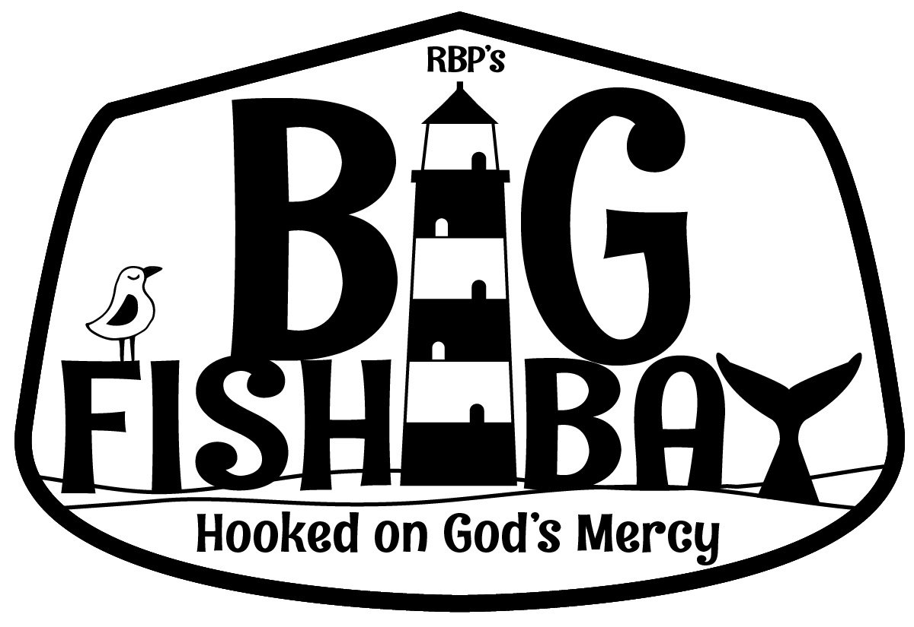
VBS at HBC - July 17-21 --- 6 to 8 pm
Pre K through 6th Grade - And YES! A Penny March
PRE-REGISTER FOR VBS…
On your computer: Go to highlandbaptistchurch.net
Bottom Right Corner under “Recent Messages”
On Your Mobile: Go to Highlandbaptistchurch.net
Scowl to the bottom of the page - “Sign Up for VBS”
Sunday 10:30 Worship Service
In Person and on Facebook Live
6:00 Sunday - VBS Meeting

Wednesday 6:30 - Praying &Singing

PRAY FOR AMERICA - PRAY FOR REVIVAL

Comparing Daniel 2 with Daniel 7

