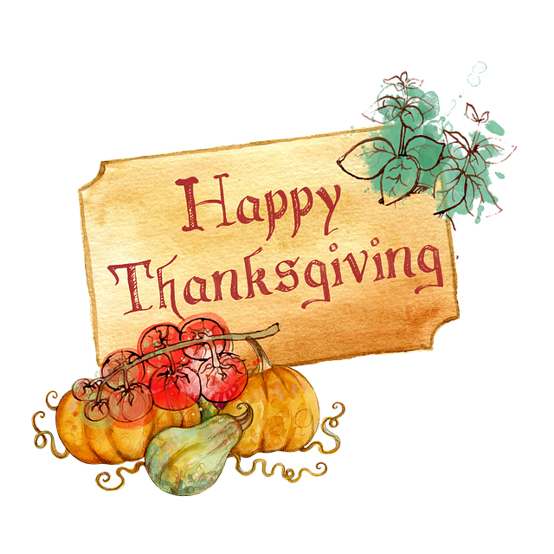
Welcome to HBC
November 19, 2023

Highland Baptist Church
1500 Husband Road, Paducah, KY 42003
Phone 270-442-6444 – Fax 270-442-3373

Pastor Dr. Richard Beck
Song Leader Mr. Carl Wilson
Music Director Dr. Carolyn Watson-Nickell

Blessed is the nation whose God is the LORD
Psalm 33:12;
______________________________________________________________________
Sunday 10:30 Worship Service
In Person and on Facebook Live
6:00 - Our Annual HBC Thanksgiving Dinner
HBC Provides the Meat - Ya’ll supply the fixins Invite Friends to attend

Wednesday Take this Wednesday to be with Family

Helping Hand Food Pantry will not be open this week

Pray for Revival - For America - For the Peace of Israel
--------------------------------------------------------------------------
This Thanksgiving Morning we want to encourage all of our HBC family and friends to read these passages of Scripture. Knowing that as you read, we will be sharing the moment with you. Bro. Beck

Let Us Sing Songs of Praise
Psalm 95:1 O come, let us sing unto the LORD: let us make a joyful noise to the rock of our salvation.
2 Let us come before his presence with thanksgiving, and make a joyful noise unto him with psalms.
3 For the LORD is a great God, and a great King above all gods.
4 In his hand are the deep places of the earth: the strength of the hills is his also.
5 The sea is his, and he made it: and his hands formed the dry land.

His Steadfast Love Endures Forever
Psalm 100:1 A Psalm of praise. Make a joyful noise unto the LORD, all ye lands.
2 Serve the LORD with gladness: come before his presence with singing.
3 Know ye that the LORD he is God: it is he that hath made us, and not we ourselves; we are his people, and the sheep of his pasture.
4 Enter into his gates with thanksgiving, and into his courts with praise: be thankful unto him, and bless his name.
5 For the LORD is good; his mercy is everlasting; and his truth endureth to all generations.

