Welcome to HBC
November 26, 2023

Highland Baptist Church
1500 Husband Road, Paducah, KY 42003
Phone 270-442-6444 – Fax 270-442-3373

Pastor Dr. Richard Beck
Song Leader Mr. Carl Wilson
Music Director Dr. Carolyn Watson-Nickell

Blessed is the nation whose God is the LORD
Psalm 33:12;
______________________________________________________________________

Sunday 10:30 Worship Service
In Person and on Facebook Live
6:00 - The Rest of the Story

Wednesday 6:30 - Prayer & Choir Practice for Christmas

Pray for Revival - For America - For the Peace of Israel

--------------------------------------------------------------------------

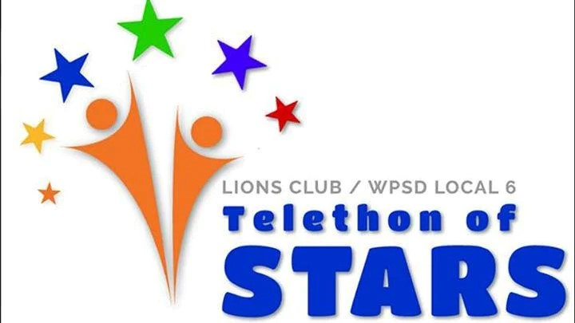

The 67th annual Telethon of Stars — a family-friendly night of entertainment that raises money for local centers providing care for adults and children with disabilities — is being held from 6:30-10 p.m. on December 2 at Easter Seals West Kentucky.

Luke 6:38 Give, and it shall be given unto you; good measure, pressed down, and shaken together, and running over, shall men give into your bosom. For with the same measure that ye mete withal it shall be measured to you again.

