Welcome to HBC
January 21, 2024

Highland Baptist Church
1500 Husband Road, Paducah, KY 42003
Phone 270-442-6444 – Fax 270-442-3373

Pastor Dr. Richard Beck
Song Leader Mr. Carl Wilson
Music Director Dr. Carolyn Watson-Nickell
Bless the LORD, O my soul: and all that is within me, bless his holy name. Psalm 103:1;
______________________________________________________________________

Welcome to the Year of Our Lord 2024 AD

Spring Banquet - February 10 @ 5:30

Menu: Your choice of Steak or Chicken,
Vegetable, Mashed Potatoes, Desert
Tickets are $10.00 per person
Purchase By February 5

Daylight Savings Begins March 10

Anniversary Weekend - March 16 & 17

Resurrection Sunday - Easter - March 31

Sunday 10:30 Worship Service

Wednesday 6:30 - Hour of Prayer

Pray for Revival - For America - For the Peace of Israel

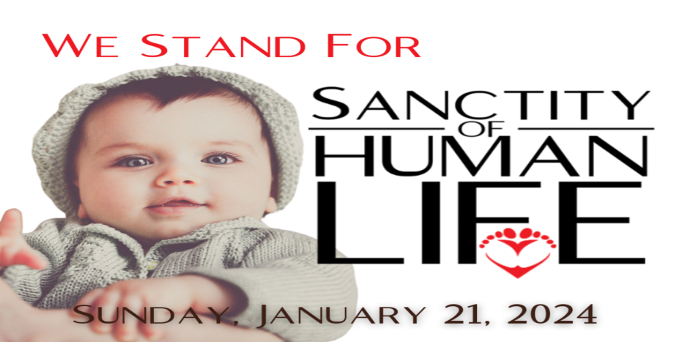

For thou hast possessed my reins: thou hast covered me in my mother's womb.
I will praise thee; for I am fearfully and wonderfully made: marvellous are thy works; and that my soul knoweth right well.
15 My substance was not hid from thee, when I was made in secret, and curiously wrought in the lowest parts of the earth.
16 Thine eyes did see my substance, yet being unperfect; and in thy book all my members were written, which in continuance were fashioned, when as yet there was none of them.
17 How precious also are thy thoughts unto me, O God! how great is the sum of them!
Psalms 139:13-17

