Welcome to HBC
January 28, 2024

Highland Baptist Church
1500 Husband Road, Paducah, KY 42003
Phone 270-442-6444 – Fax 270-442-3373

Pastor Dr. Richard Beck
Song Leader Mr. Carl Wilson
Music Director Dr. Carolyn Watson-Nickell
Bless the LORD, O my soul: and all that is within me, bless his holy name. Psalm 103:1;
______________________________________________________________________

Welcome to the Year of Our Lord 2024 AD

Spring Banquet - February 10 @ 5:30

Menu: Your choice of Steak or Chicken,
Vegetable, Mashed Potatoes, Desert
Tickets are $10.00 per person
Purchase By February 5

Daylight Savings Begins March 10

Anniversary Weekend - March 16 & 17

Resurrection Sunday - Easter - March 31

Sunday 10:30 Worship Service

Wednesday 6:30 - Hour of Prayer

Pray for Revival - For America - For the Peace of Israel

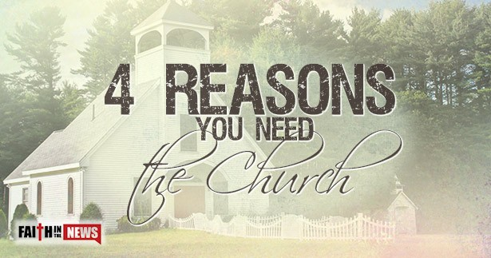
I know of no lone-ranger Christians anywhere in the New Testament church. They always met together, broke bread, and had fellowship. Acts 2:42 says, “And they continued stedfastly in the apostles' doctrine and fellowship, and in breaking of bread, and in prayers.” So how can you be devoted to the apostle’s teachings without assembling together and hearing teachings behind the pulpit–in Sunday school or at a Sunday or Wednesday night Bible study? The words “one another” show up dozens and dozens of times in the New Testament, and it is always in the context of the Body of Christ, the church. No, church doesn’t save you, but a saved person should desire the fellowship of the saints, as iron sharpens iron (Proverbs 27:17). The Bible teaching is very clearly stated, “Not forsaking the assembling of ourselves together, as the manner of some is; but exhorting one another: and so much the more, as ye see the day approaching.”(Hebrews 10:25). That day is apparently swiftly approaching, and we need one another all the more to “exhort (encourage) one another” (Hebrews 3:13). Copied & Adapted

