Welcome to ***HBC***

***September 8, 2024***

***H****ighland* ***B****aptist* ***C****hurch*

1500 Husband Road, Paducah, KY 42003

Phone 270-442-6444 – Fax 270-442-3373

Pastor Dr. Richard Beck

Song Leader Mr. Carl Wilson

Music Director Dr. Carolyn Watson-Nickell

***Bless the LORD, O my soul: and all that is within me bless his holy name*.** Psalm 103:1;

***HBC Welcomes the Ministry of***

***Eric & Debby Horner***

______________________________________________________________________

Month of September in the Year of Our Lord 2024

**Sunday** 10:30 - Worship Service

**Wednesday** 6:30 - Prayer

**Saturday** Men’s Breakfast @ 8:30

At MLC’s off Exit 16

*(MLC’s is closing on the 15th***)**

---------------------------------------------------------------------------------

***Pray For Revival - For America - For the Peace of Israel***

**-**

**September 15**

**National BACK to CHURCH Sunday**

**Let’s ALL Attend and Bring a Friend**

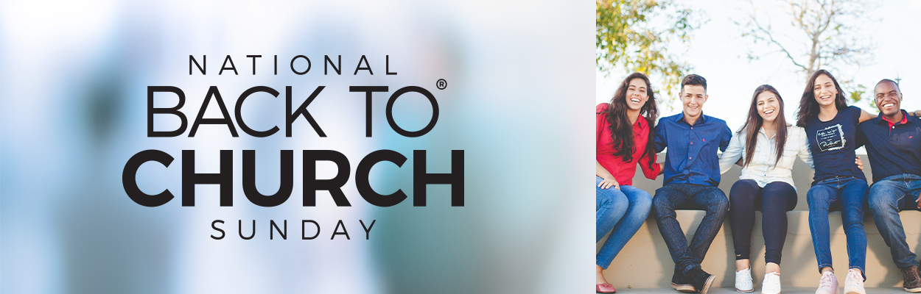

**_____________________________**

**September 22**

**A Missions Message from**

**Dr. Jack Alumbaugh**

**-----------------------------**

**October 20**

**Faith Promise Missions Offering**

**---------------------------------**



**October 27**

**Annual Bon Fire and Chili Service**

**at the home of Donnie & Lou Gilbert**