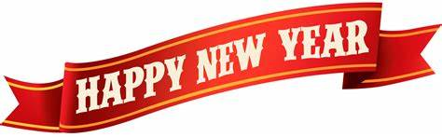

Welcome to ***HBC***

***December 29, 2024***

***H****ighland* ***B****aptist* ***C****hurch*

1500 Husband Road, Paducah, KY 42003

Phone 270-442-6444 – Fax 270-442-3373

Pastor Dr. Richard Beck

Song Leader Mr. Carl Wilson

Music Director Dr. Carolyn Watson-Nickell

***Blessed is the nation whose God is the LORD***

Psalm 33:12;

______________________________________________________________________

**DECEMBER In the Year of Our Lord 2024**

**Sunday** 10:30 Worship Service

*In Person and on Facebook Live*

**Join Us Tonight @ 6 pm**

Fellowship, Food and a Special Guest

Dr. Shari Baskin

**Saturday**  Men’s Breakfast @ 8:30

Little Castle in Lone Oak

***Pray For Revival - For America - For the Peace of Israel***

***Cannot find the right words…***

*Your thoughtfulness, kindness and giving of your time to organize and then attend our 50th anniversary was a surprise and a great blessing to us****.***

*We read each of the cards again when we arrived home and prayed God’s special blessing on each one who gave of themselves and finances.*

*As we shared with those attending we will use your gift of $1,000.00 (less the tithe) to help pay for some unexpected dental work. It will cost $9,600.00 and, as you know, Medicare does not cover dental. Your gift was a great blessing. THANK YOU so very much.*

*As we end 2024 and begin 2025 we cannot think of a better place and better people to be with than HBC!!!*

*In Christian and Personal Love to All,*

***Bro. Beck & Valerie***

**_______________________________________**

With great excitement we will present to those who signed up, a daily Bible reading plan for 2025.

During and after we finished binding each one together we prayed for God’s blessing on those who have committed to read the Bible daily.

Nothing brings us into a personal relationship with our heavenly Father as daily Bible reading.

It enhances our prayers, enables us to have strength to face the challenges of the world.

Two verses come to mind…

*Thy word have I hid in mine heart, that I might not sin against thee*.  Psalms 119:11;

*And thou shalt love the LORD thy God with all thine heart, and with all thy soul, and with all thy might. And these words, which I command thee this day, shall be in thine heart:*  Deuteronomy 6:5-6;