Welcome to ***HBC***

***January 26, 2025***

***H****ighland* ***B****aptist* ***C****hurch*

1500 Husband Road, Paducah, KY 42003

Phone 270-442-6444 – Fax 270-442-3373

Pastor Dr. Richard Beck

Song Leader Mr. Carl Wilson

Music Director Dr. Carolyn Watson-Nickell

***Blessed is the nation whose God is the LORD***

Psalm 33:12;

______________________________________________________________________

***Today we continue our study of I Peter***

Honour all *men.* Love the brotherhood. Fear God. Honour the king.  I Peter 2:17;

**JANUARY In the Year of Our Lord 2025**

**Sunday** 10:30 - Worship Service

*In Person and on Facebook Live*

6:00 - The Rest of the Message

**Wednesday**  6:30 - Prayer & Choir Practice

________________________________________________________________________

**Spring Banquet - Sunday, February 9 @ 5 pm**

Chicken, Ham. Beef, Vegetables, Dessert, Beverage

$15.00 per person - Sign -up By February 2nd

Sign-up Sheet on the White Table by the Sound Booth

------------------------------------------------------------------------

***Pray For Revival - For America - For the Peace of Israel***

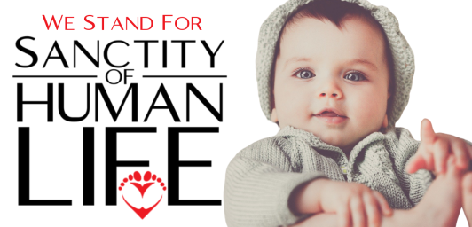

**Total number of abortions in US   
(1973 – 2020):**

63.6 million+

**Number of abortions in US   
(2020):**

930,160

**Abortions per day:**

2,548

**Abortions per hour:**

106

1 Abortion every  
34 seconds!

**Information from**[**All Am**e**rican Life League**](https://www.all.org/learn/abortion/abortion-statistics/)