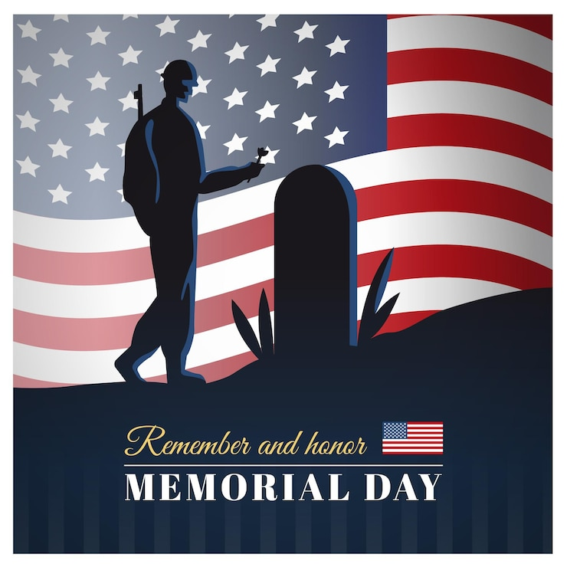

***May 25, 2025***

***Blessed is the nation whose God is the LORD***

Psalm 33:12;

Welcome to ***HBC***

***Highland Baptist Church***

1500 Husband Road, Paducah, KY 42003

Phone 270-442-6444 – Fax 270-442-3373

Pastor Dr. Richard Beck

Song Leader Mr. Carl Wilson

Music Director Dr. Carolyn Watson-Nickell

______________________________________________________________________

**MAY In the Year of Our Lord 2025**

**Sunday** 10:30 - Worship Service

*In Person and on Facebook Live*

Sunday Evening Service will be designated as VBS preparation time!

On Sunday, June 1 at 5 pm we will have a special meeting

of all VBS workers.

Go over schedules, Insights into Crafts and Refreshments.

**Wednesday**  6:30 - Studies in Philippians Continued

**____________________________________________________**

*PRAY FOR AMERICA ------- PRAY FOR REVIVAL PRAY FOR ISRAEL*



THE PRICE OF FREEDOM

AMERICAN REVOLUTION

1775 – 1783 - 24,435 CASUALTIES

WAR OF 1812

1812 – 1815 – 2,260 CASUALTIES

CIVIL WAR

1861 – 1865 - 625,000 CASUALTIES

WORLD WAR I

1917 – 1918 – 116, 516 CASUALTIES

WORLD WAR II

1941 – 1945 – 405,399 CASUALTIES

KOREAN WAR

1950 – 1953 – 36,574 CASUALTIES

VIETNAM WAR

1964 – 1975 – 58,220 CASUALTIES

DESERT SHIELD / DESERT STORM

1990 – 1991 – 383 CASUALTIES

ENDURING FREEDOM & Others

2001 – Present 7,028 & Counting