June 15, 2025

Blessed is the nation whose God is the LORD
Psalm 33:12;
Father’s Day 2025
Welcome to HBC
Highland Baptist Church
1500 Husband Road, Paducah, KY 42003
Phone 270-442-6444 – Fax 270-442-3373

Pastor Dr. Richard Beck
Song Leader Mr. Carl Wilson
Music Director Dr. Carolyn Watson-Nickell
______________________________________________________________________
We Greatly Rejoice
VBS 2025 - On Track with Our Powerful God
After months of planning, hard work, preparation and prayer VBS week arrived - we went “Full Throttle for God”. The HBC Staff gave their all to have a ministry with Pre-K through 6th grade children. Only eternity will reveal the greatness of the impact we left when the week was finished.
We greatly rejoice that 5 came to the knowledge of salvation and received Christ as Savior. Give glory to God and pray for these new members of God’s eternal family! May they grow in grace and knowledge of God.
On a lighter note, our first ever Foam Party was spectacular (that means very awesome). Thanks to all who donated to make it possible.
.
JUNE In the Year of Our Lord 2025

Sunday 10:30 - Worship Service
In Person and on Facebook Live

6:00 - The Rest of the Sermon

Wednesday 6:30 - Prayer & Philippians

Mark Your Calendar -Prayer Breakfast- June 28th
Men at 8:30 --- Ladies at 10:00
____________________________________________________
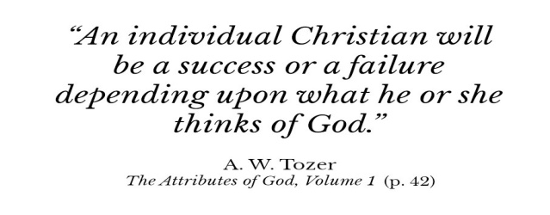
Christianity at any given time is strong or weak depending upon her concept of God. And I insist upon this and I have said it many times, that the basic trouble with the Church today is her unworthy conception of God. I talk with learned and godly people all over the country, and they’re all saying the same thing.
The psalmist said, “O magnify the LORD with me” (34:3). “Magnify” may mean one of two things: “make it look bigger than it is,” or “see it as big as it is.” The latter is what “magnify” means as the psalmist used it.
If you want to examine a very small amount of matter, you put it under a microscope and magnify it to make it look bigger than it is. But it is impossible to make God look bigger than He is. When we say “magnify the Lord,” we mean try to see God somewhere near as big as He is. This is what I want to do. This is what, by His help, I have dedicated myself to do.
A local church will only be as great as its conception of God. An individual Christian will be a success or a failure depending upon what he or she thinks of God. It is critically important that we have a knowledge of the Holy One, that we know what God is like. Of course we can know from the Scriptures—that’s where we go to get our information. We can know some of it from nature too: “The heavens declare the glory of God; and the firmament showeth his handiwork” (Psalm 19:1). But while the pen of nature writes without too much clarity, the Word of God is very, very clear.
Excerpted from The Attributes of God, Volume 1 p. 40-42.

