June 22, 2025

Blessed is the nation whose God is the LORD
Psalm 33:12;
Welcome to HBC
Highland Baptist Church
1500 Husband Road, Paducah, KY 42003
Phone 270-442-6444 – Fax 270-442-3373

Pastor Dr. Richard Beck
Song Leader Mr. Carl Wilson
Music Director Dr. Carolyn Watson-Nickell
______________________________________________________________________
JUNE In the Year of Our Lord 2025

Sunday 10:30 - Worship Service
In Person and on Facebook Live

6:00 - The Rest of the Sermon

Wednesday 6:30 - Prayer & Philippians

Saturday Prayer Breakfast
Men at 8:30 --- Ladies at 10
Little Castle in Lone Oak - Back Room

____________________________________________________


PRAY FOR REVIVAL --- PRAY FOR AMERICA
--- PRAY FOR ISRAEL

Today we focus on the life of Moses.
Perhaps the greatest type of Christ in the Bible
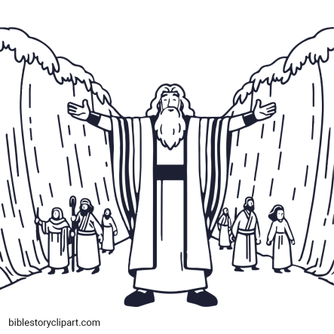

Scripture Reading - Deuteronomy 34:7-12;

7 And Moses was an hundred and twenty years old when he died: his eye was not dim, nor his natural force abated.
8 And the children of Israel wept for Moses in the plains of Moab thirty days: so the days of weeping and mourning for Moses were ended.
9 And Joshua the son of Nun was full of the spirit of wisdom; for Moses had laid his hands upon him: and the children of Israel hearkened unto him, and did as the LORD commanded Moses.
10 And there arose not a prophet since in Israel like unto Moses, whom the LORD knew face to face,
11 In all the signs and the wonders, which the LORD sent him to do in the land of Egypt to Pharaoh, and to all his servants, and to all his land,
12 And in all that mighty hand, and in all the great terror which Moses shewed in the sight of all Israel.

