June 8, 2025

Blessed is the nation whose God is the LORD
Psalm 33:12;
Welcome to HBC
Highland Baptist Church
1500 Husband Road, Paducah, KY 42003
Phone 270-442-6444 – Fax 270-442-3373

Pastor Dr. Richard Beck
Song Leader Mr. Carl Wilson
Music Director Dr. Carolyn Watson-Nickell

______________________________________________________________________
JUNE In the Year of Our Lord 2025

Sunday 10:30 - Worship Service
In Person and on Facebook Live

Monday - Friday 6:00 - 8:00 V.B.S.
You can register for VBS online - highlandbaptistchurch.net
____________________________________________________

Father’s Day - June 15th



As we begin the VBS 2025 Outreach
Let us join together in prayer for the Ministry,
the Staff, for lives of children to be impacted.

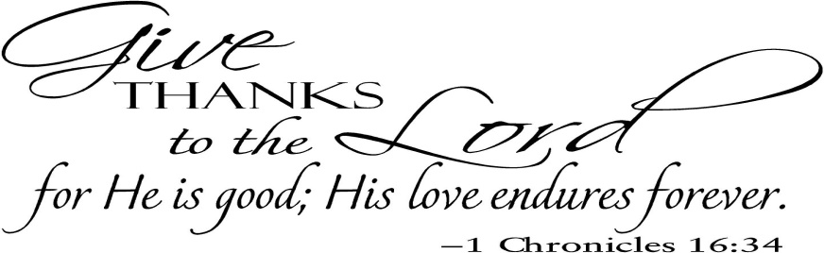

2 And Jesus called a little child unto him, and set him in the midst of them, 3 And said, Verily I say unto you, Except ye be converted, and become as little children, ye shall not enter into the kingdom of heaven. 4. Whosoever therefore shall humble himself as this little child, the same is greatest in the kingdom of heaven. 5 And whoso shall receive one such little child in my name receiveth me. Matthew 18:2-5

