November 9, 2025

Welcome to HBC
Highland Baptist Church
1500 Husband Road, Paducah, KY 42003
Phone 270-442-6444 – Fax 270-442-3373

Pastor Dr. Richard Beck
Song Leader Mr. Carl Wilson
Music Director Dr. Carolyn Watson-Nickell
____________________________________________________________________

NOVEMBER In the Year of Our Lord 2025

Sunday 10:30 - Worship Service
In Person and on Facebook Live

6:00 - The Rest of the Sermon

Wednesday 6:30 - Choir Practice Only

Saturday 7:30 - Men’s Breakfast at MLC’s
9:30 - Ladies Breakfast at MLC’s
Church Cleaning After Breakfast
------------------------------------------------

HBC Annual
Thanksgiving Dinner
November 23 @ 6 pm

HBC will provide the meats…
You bring the fixins, the victuals
(veggies, salad dish, dessert,)

FELLOWSHIP & FOOD!!!
Invite someone to attend

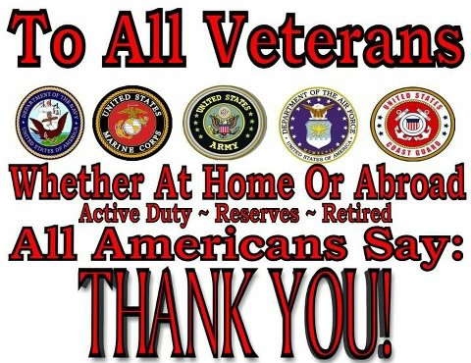
On Veterans Day, we should honor the service and sacrifice of members of our Armed Forces, both past and present, as well as their families. Interestingly, Paul compares the Christ-follower to a soldier in the military, encouraging us to: “Thou therefore endure hardness, as a good soldier of Jesus Christ. No man that warreth entangleth himself with the affairs of this life; that he may please him who hath chosen him to be a soldier.” (II Timothy 2:3-4). Being a good soldier requires discipline and sacrifice. That is certainly true in our Armed Forces, whom we honor on Veterans Day. As Americans, we owe our freedom to God who gave it and to the members of the United States military who guard and protect it. The cost of maintaining our freedom is great. The fight for freedom is never over. We must fight to win it, and then we must fight to keep it. Just survey our rich history and heritage of military service. From the Minute Men who were out-manned and out-gunned by the British in Lexington and Concord, to General Washington and his ill clad men enduring the harsh winter at Valley Forge, to the rocket’s red glare over Fort McHenry in the War of 1812, to the blood soaked fields around Gettysburg where brother fought against brother, to the Doughboys in the trenches facing sniper fire and mustard gas in WWI, to the scores of Sailors who died at Pearl Harbor, to the Soldiers who stormed the beaches of Normandy, to the Airmen who flew bombing raids over Tokyo, to the Marines who fought on the shores of Iwo Jima, on the frigid hills of Korea, the jungles of Vietnam, the deserts of Iraq, and the rugged mountains of Afghanistan —these Patriots secured our liberty at a high price. They deserve our gratitude and respect.

