January 11 2026

Welcome to HBC
Highland Baptist Church
1500 Husband Road, Paducah, KY 42003
Phone 270-442-6444 – Fax 270-442-3373

Pastor Dr. Richard Beck
Song Leader Mr. Carl Wilson
Music Director Dr. Carolyn Watson-Nickell

Blessed is the nation whose God is the LORD
Psalm 33:12;
____________________________________________________________________

JANUARY In the Year of Our Lord 2026

Sunday 10:30 - Worship Service
In Person and on Facebook Live

6:00 “The Rest of the Sermon”
Tonight VBS 2026 Review

Wednesday 6:30 - Choir Practice Only

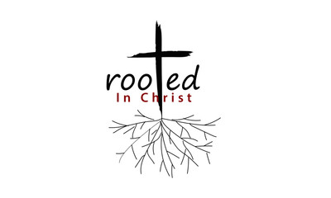
That Christ may dwell in your hearts by faith; that ye, being rooted and grounded in love,
May be able to comprehend with all saints what is the breadth, and length, and depth, and height;
And to know the love of Christ, which passeth knowledge, that ye might be filled with all the fulness of God. Ephesians 3:17-19;

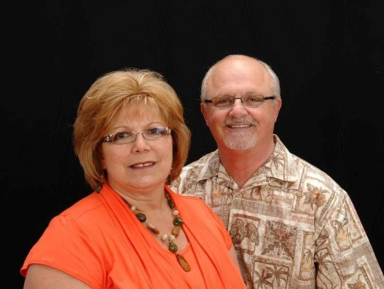
Dan & Gail Powers
Missionaries to Cambodia
Dan and Gail Powers spent over 25 years in the Pastoral Ministry until they were called into International Ministries. They became missionaries to Cambodia in 2010.

Quotes with Words of Encouragement

- “God is still writing your story.” Even when life feels chaotic, God is at work. Trust His timing and His plan.

- “What you are facing may be big, but your God is bigger.” He who parted the sea, calmed the storm, and raised the dead is with you.

- “Faith does not always take the pain away, but it gives you strength to face it.” Lean not on your own understanding; hold fast to God’s promises.

- “You may feel forgotten, but God never loses sight of His children.” Let your conversation be without covetous ness; and be content with such things as ye have: for he hath said, I will never leave thee, nor forsake thee. Hebrews 13:5;

- “Victory is on the other side of this valley.” Keep walking. Even the darkest night will break into dawn.

- “The cross was not the end of Jesus’ story - and this won’t be the end of yours”. Resurrection power lives in you.
That I may know him, and the power of his resurrection,
Philippians 3:10;

