January 18, 2026

Welcome to HBC
Highland Baptist Church
1500 Husband Road, Paducah, KY 42003
Phone 270-442-6444 – Fax 270-442-3373

Pastor Dr. Richard Beck
Song Leader Mr. Carl Wilson
Music Director Dr. Carolyn Watson-Nickell

Blessed is the nation whose God is the LORD
Psalm 33:12;
____________________________________________________________________

Sanctity of Human Life Sunday 2026

Every human life is a sacred gift from God—created in His image, known before birth, and cherished to life’s final breath.

On January 22, 1984 President Ronald Reagan issued a presidential proclamation designating the third Sunday of January
“National Sanctity of Human Life Sunday”

"Before I formed you in the womb I knew you, before you were born I set you apart; I appointed you as a prophet to the nations” - Jeremiah 1:5
JANUARY In the Year of Our Lord 2026

Sunday 10:30 - Worship Service
In Person and on Facebook Live

6:00 “The Rest of the Sermon”

Monday 4:45 - Leadership Meeting

Saturday 7:30 - Men’s Breakfast at MLC’s

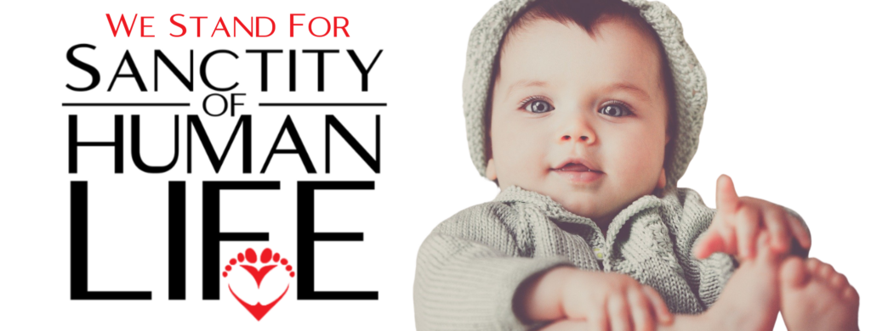

For thou hast possessed my reins: thou hast covered me in my mother's womb. I will praise thee; for I am fearfully and wonderfully made: marvellous are thy works; and that my soul knoweth right well. Psalm 139; 13, 14;

At 4 weeks - The heart, now in a tubular form, begins to beat by the 25th day.

At 6 weeks - Electrical activity begins developing brain and nervous system.

At 6 weeks - Arms, legs, hands, toes and face begin to form. The baby begins small random movements.

[A Doctor described a baby in a tubal pregnancy (again 6 weeks, because after that, the tube ruptures). The Doctor said he saw the baby swimming around in the sac once a second with a natural swimmers stroke].

At 10 weeks - The heart can be detected electronically.

At 12 weeks - The baby is able to swallow and the kidneys are able to make urine. Blood begins to form in the bone marrow.

At 16 weeks- The baby can kick and sleep.

At 28 weeks - The baby has lungs that can breathe air.

At 32 weeks - the baby can grasp firmly.

At 38 weeks - The baby has reached full term and is ready to be born.

A 40 weeks - Mom hopes the baby will be born SOON.

