January 4, 2026

Welcome to HBC
Highland Baptist Church
1500 Husband Road, Paducah, KY 42003
Phone 270-442-6444 – Fax 270-442-3373

Pastor Dr. Richard Beck
Song Leader Mr. Carl Wilson
Music Director Dr. Carolyn Watson-Nickell

Blessed is the nation whose God is the LORD
Psalm 33:12;
____________________________________________________________________

JANUARY In the Year of Our Lord 2026

Sunday 10:30 - Worship Service
In Person and on Facebook Live

6:00 “The Rest of the Sermon”

Wednesday 6:30 - Prayer & Choir Practice

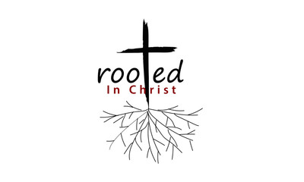
As ye have therefore received Christ Jesus the Lord, so walk ye in him: Rooted and built up in him, and stablished in the faith, as ye have been taught, abounding therein with thanksgiving.
Colossians 2:6, 7;
As You Begin 2026 REMEMBER…
The battles you won in 2025
The prayers God answered
The peace God gave in the storms of life
GOD is bigger than your pain
GOD is bigger than your fears
GOD is bigger your problems
You are not walking into 2026 alone.
GOD IS ALREADY AHEAD OF YOU
Preparing, aligning, protecting
In His love we find peace,
In His Word we find wisdom,
In His service we find purpose

Trust in the LORD with all thine heart; and lean not unto thine own understanding. In all thy ways acknowledge him, and he shall direct thy paths. Be not wise in thine own eyes: fear the LORD, and depart from evil. Proverbs 3:5-7;

Today’s Scripture - I Corinthians 4:1-5;

I Corinthians 4:1; Let a man so account of us, as of the ministers of Christ, and stewards of the mysteries of God.
2 Moreover it is required in stewards, that a man be found faithful.
3 But with me it is a very small thing that I should be judged of you, or of man's judgment: yea, I judge not mine own self.
4 For I know nothing by myself; yet am I not hereby justified: but he that judgeth me is the Lord.
5 Therefore judge nothing before the time, until the Lord come, who both will bring to light the hidden things of darkness, and will make manifest the counsels of the hearts: and then shall every man have praise of God.

PRAY FOR
REVIVAL IN AMERICA --- PEACE OF ISRAEL

