April 12, 2026,

Welcome to HBC
Highland Baptist Church
1500 Husband Road, Paducah, KY 42003
Phone 270-442-6444 – Fax 270-442-3373

Pastor Dr. Richard Beck
Song Leader Mr. Carl Wilson
Music Director Dr. Carolyn Watson-Nickell

Blessed is the nation whose God is the LORD
Psalm 33:12;
____________________________________________________________________

APRIL In the Year of Our Lord 2026

Sunday 10:30 - Worship Service
In Person and on Facebook Live

6:00 “The Rest of the Sermon”
We will discuss Summer Activity ideas

Wednesday 6:30 - Prayer Meeting

A Heart for GOD - A Vision for the WORLD
Highland Baptist Church has a growing world missionary family that presently consists of twenty missionary families and missionary projects. HBC, as a church, is committed to the world mission mandate given by Christ in Matthew 28:18-20. And Jesus came and spake unto them, saying, All power is given unto me in heaven and in earth. Go ye therefore, and teach all nations, baptizing them in the name of the Father, and of the Son, and of the Holy Ghost: 20 Teaching them to observe all things whatsoever I have commanded you: and, lo, I am with you alway, even unto the end of the world. Amen.
The Cross Answers the Four Greatest Questions
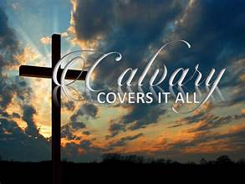
1. What is evil- sin is real and only the cross of Christ reveals its horror, devastation and grip it has on every human being and the entire creation.
2. What is justice- God publicly displayed Christ on the cross at his death as the mercy seat accessible through faith. This was to demonstrate the righteousness of God and allow God to be just and the justifier of anyone who trust Christ as their savior.
3. What is love- The most profound expression of love ever demonstrated was the cross; here is love, not that we love God but that he loved us and gave Jesus to be the atoning sacrifice for our sins.
4. What is forgiveness- The cross is the greatest display of unconditional forgiveness the world has ever witnessed. Without the shedding of blood there is no forgiveness from sin. Greg Baxter


